Logging into Exxat via SSO
Prism
Single Sign On (SSO) allows users to use one set of login credentials to access multiple applications. If your program has set up SSO, you will use your school credentials to sign onto Exxat!
Please note that you will not receive an invitation to login to Exxat. Your program or the Exxat support team will confirm once your account is activated.
- Go to steps.exxat.com.
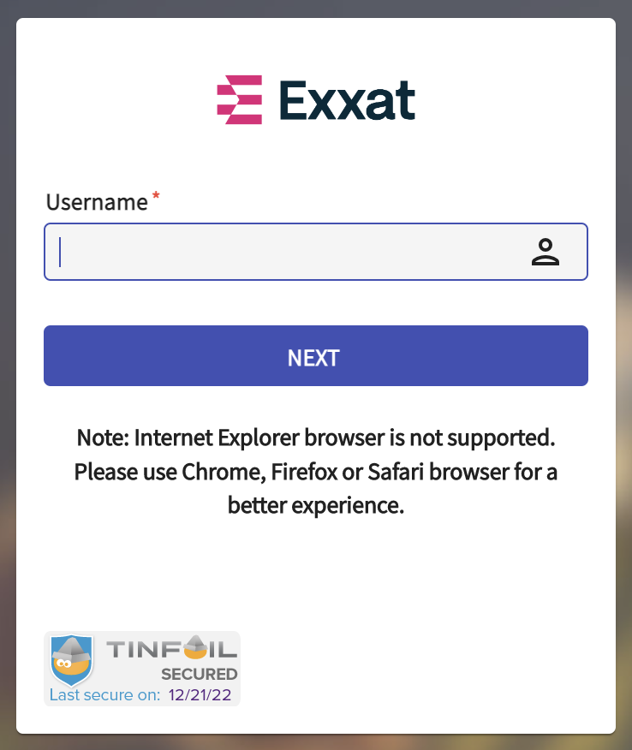

- In the username field, enter your school email address and click Next. You will be redirected to your school’s login page.

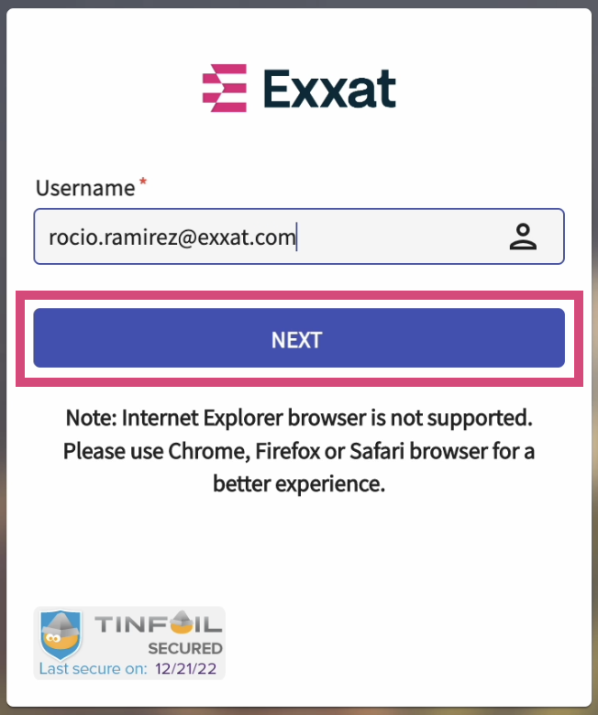

- Login to your school portal. Once done, you’ll be redirected to Exxat Prism.

